Nama : Shabrina Katresnawati

NIM :1207070136

Kelas : Teknik Elektro TKK

**Praktikum 6 Pengolahan Citra Digital**

**Flip Gambar**

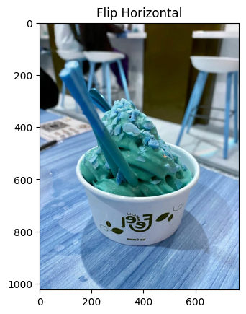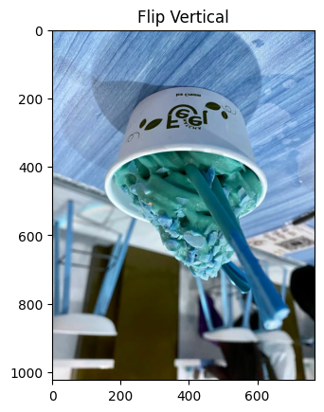

## Histogram

## 

## Histogram Gambar Grayscale

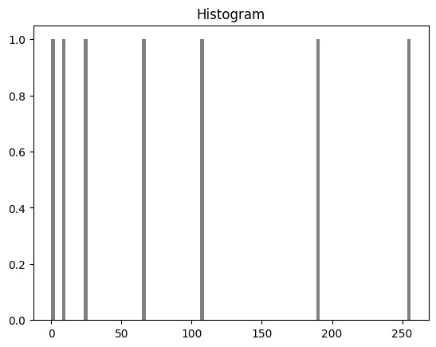

## Histogram Gambar RGB¶

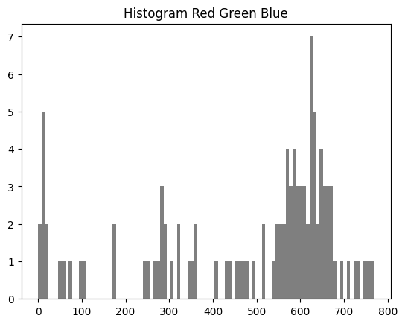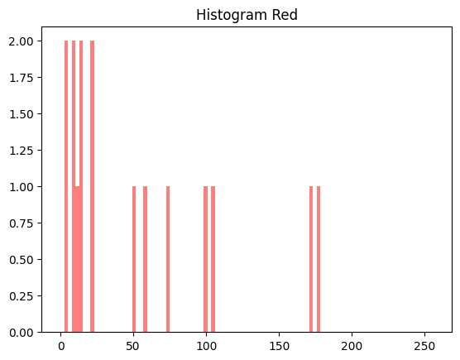

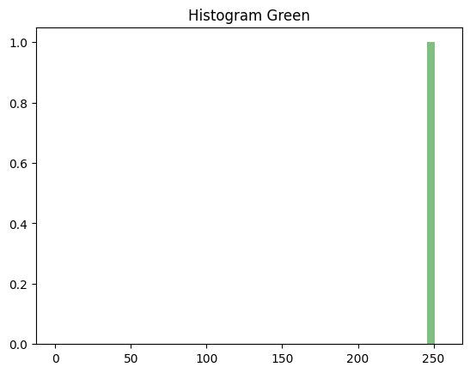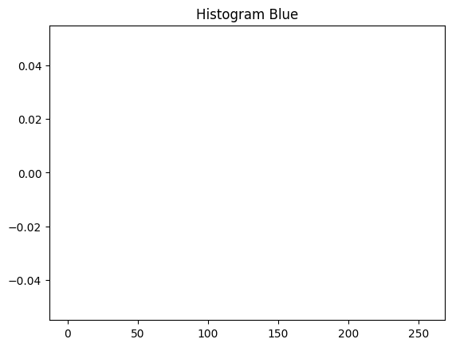

## Histogram Kumulatif

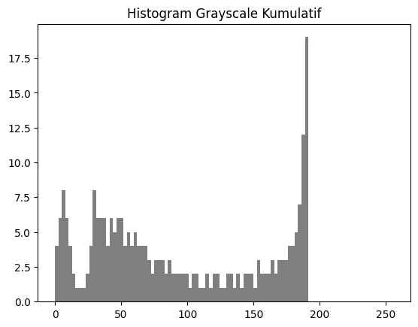

## Histogram Hequalisasi¶

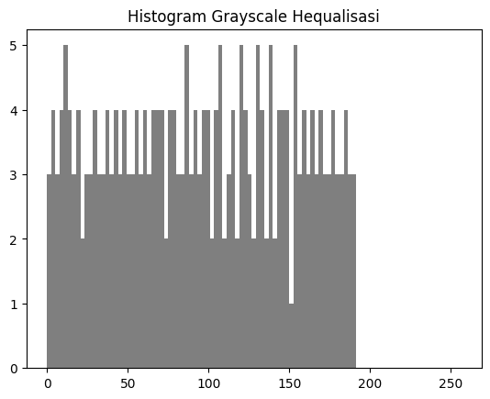

## Inversi

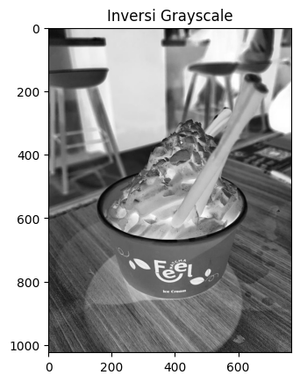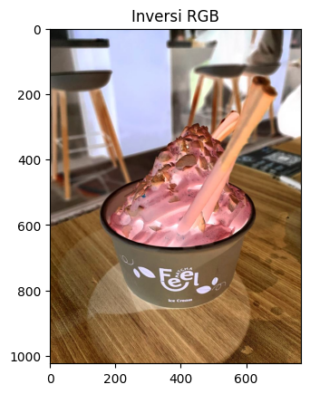

## Log

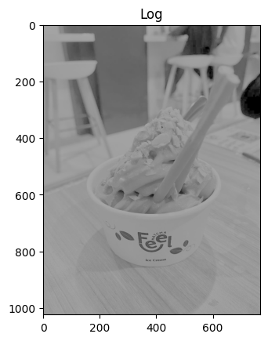

## Inversi & Log

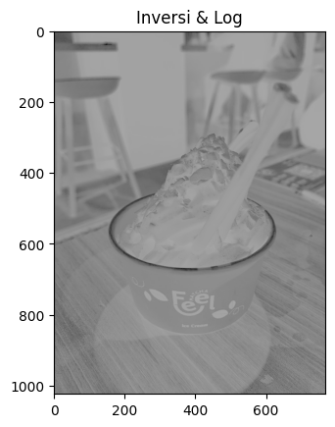

## Nth Power¶

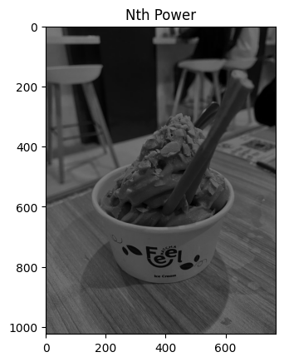

## Nth Root Power

